**108**

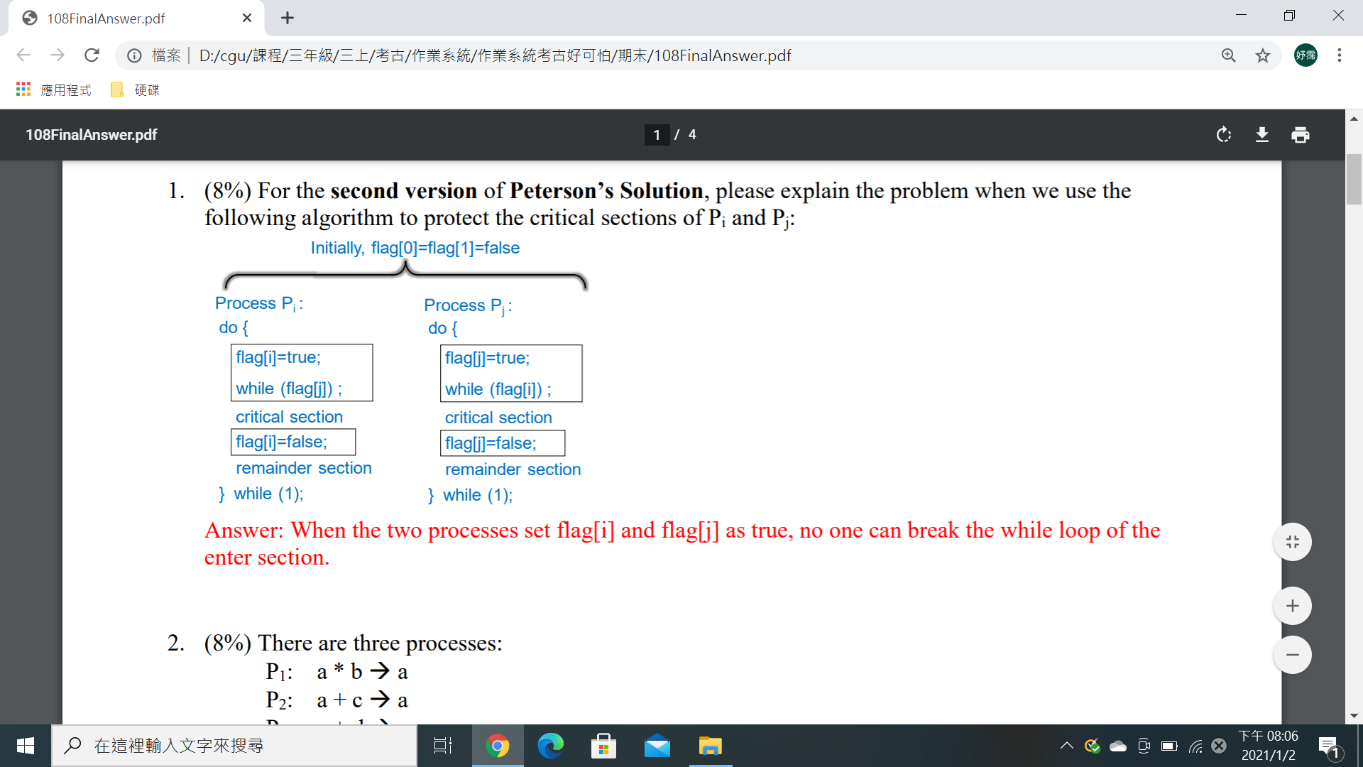

Ans：當兩個processes將flag[i]和flag[j]設置為true時，沒有人可以中斷enter section的while loop

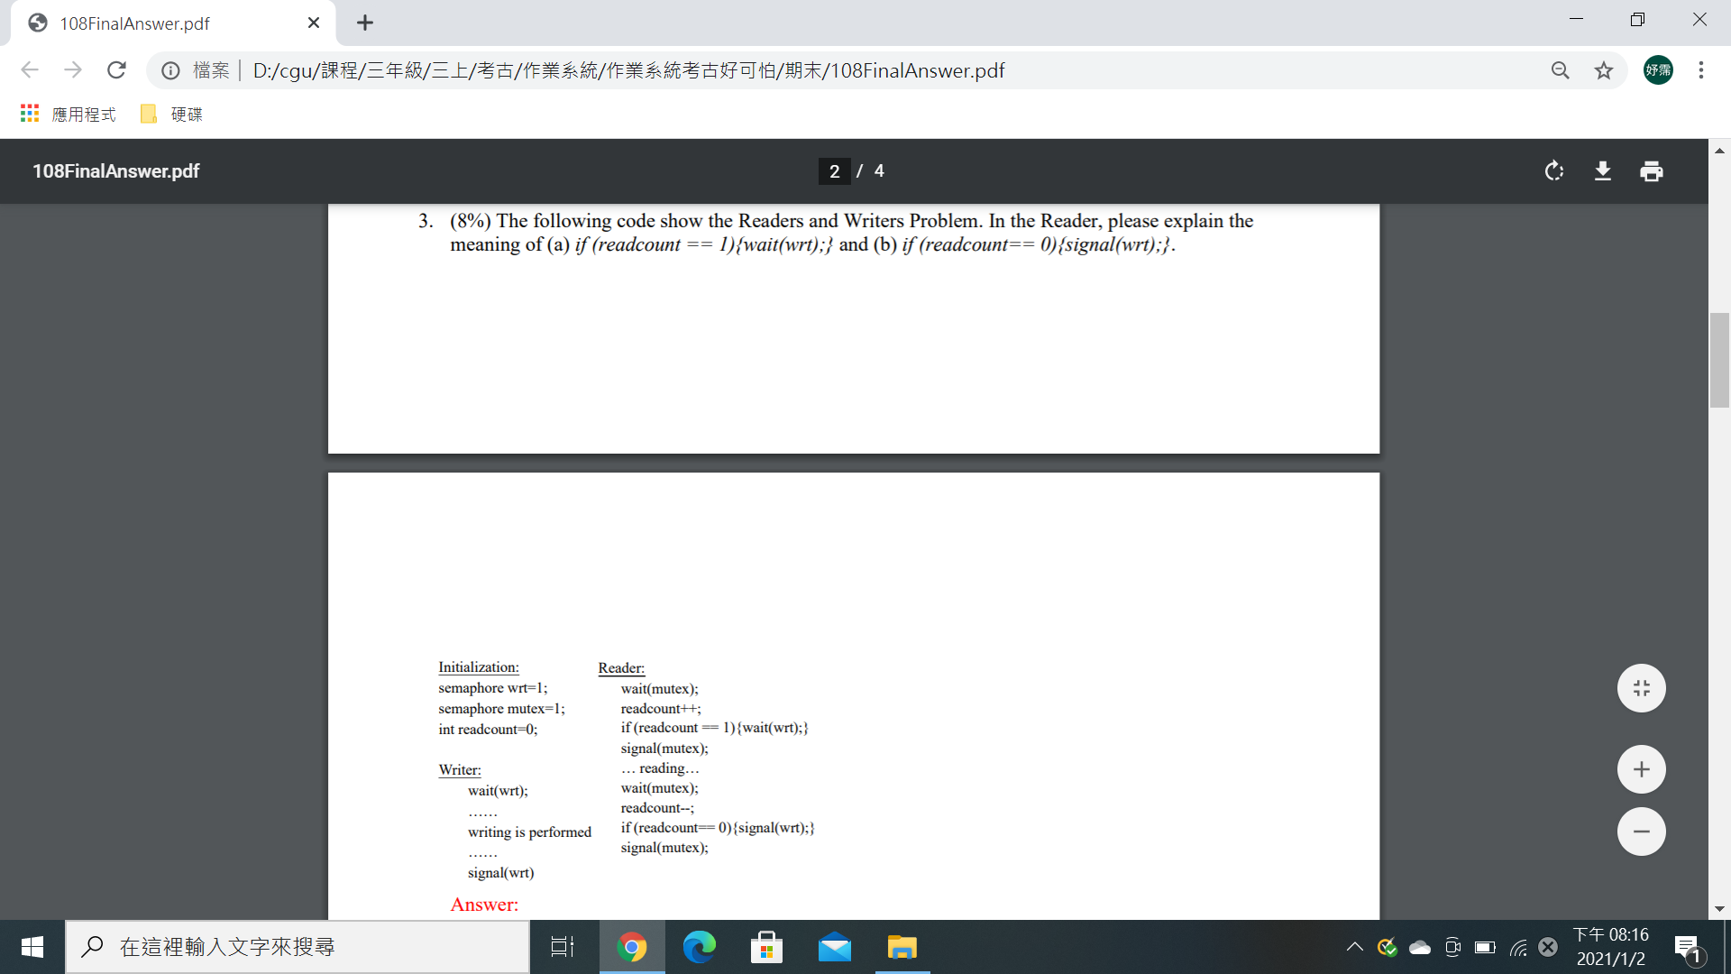



(a)當第一個reader想使用共享資源時，他必須檢查有沒有writer在使用共享資源

(b)當最後一個reader完成對共享資源的訪問時，他必須釋放semaphore以使writer使用共享資源

**4.** Deadlock Prevention is to prevent the four necessary conditions of deadlock. Please explain the four necessary conditions: (a) mutual exclusion, (b) hold and wait, (c) no preemption, and (d) circular wait.

(a)一次只有一個process可以使用資源

(b)一個process持有至少一個resource正在等待獲得額外被其他process持有的resource

(c)resource只能由持有他的process自願釋放

(d) The waiting process chain forms a circle

**6.** For memory management with page tables, considering the following figure, please answer the questions: (a) What is p? (b) What is f? (c) what is d? (d) What is the function of TLB?

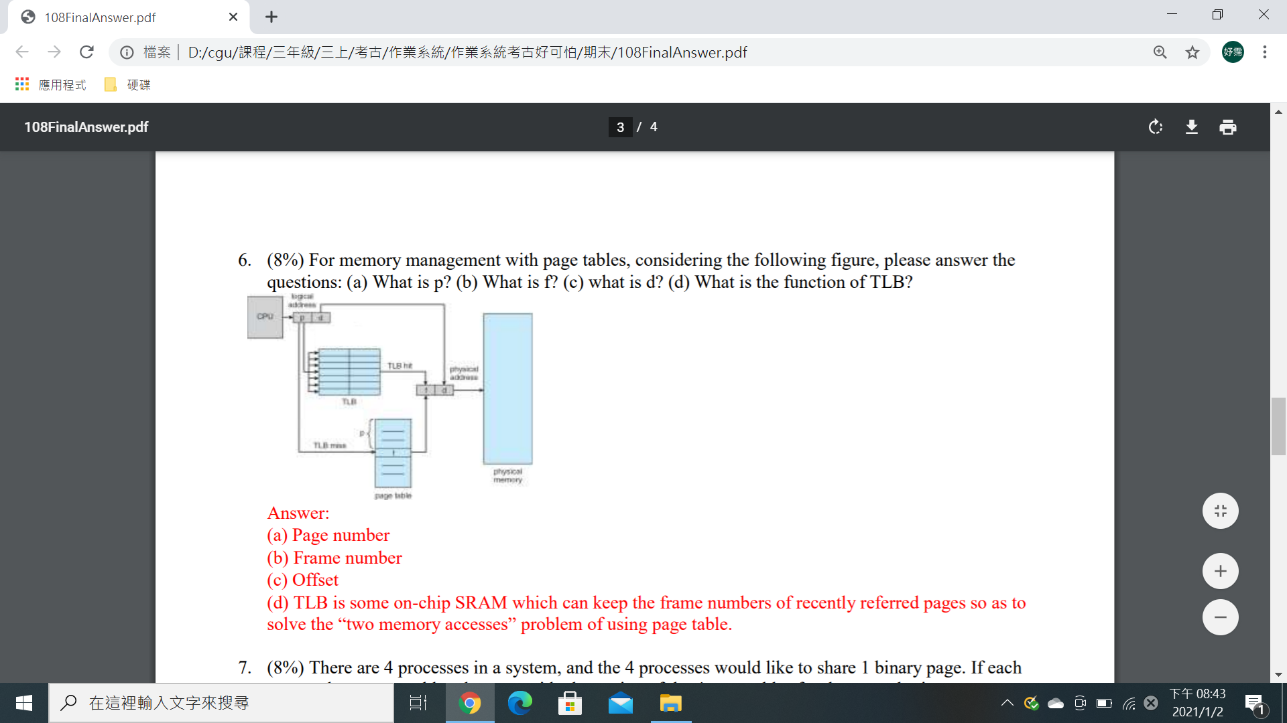(a) Page number

(b) Frame number

(c) Offset

(d) TLB是一些on-chip SRAM可以保留最近引用頁面的frame，以便解決在使用page table時two memory accesses的問題

**7.**There are 4 processes in a system, and the 4 processes would like to share 1 binary page. If each process has a page table, please provide the setting of the 4 page tables for the page sharing.

Ans：讓每一個page table有一個節點，for mapping a page to the same physical memory frame.

**8.** For the inverted page table architecture, please briefly explain the mechanism of inverted page table architecture for getting the physical address.

Ans：它在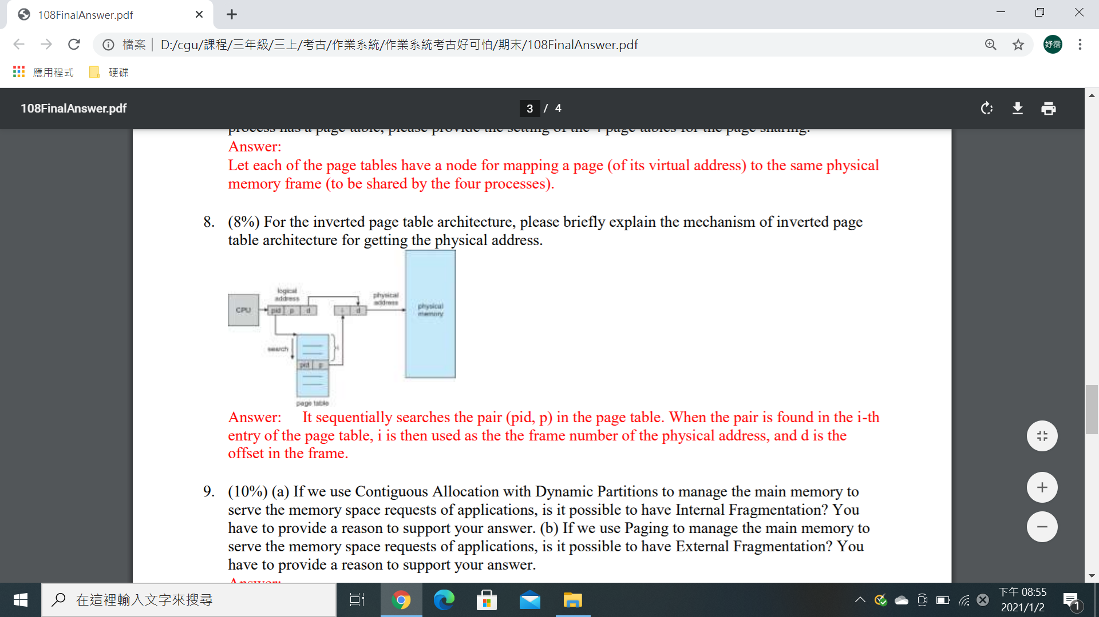page table中循序搜尋pair(pid,p)，當這個pair在page table的第i個entry被找到，i就會被用來當作physical address的frame number，而d就是frame中的offset。

**9.** (a) If we use Contiguous Allocation with Dynamic Partitions to manage the main memory to serve the memory space requests of applications, is it possible to have Internal Fragmentation? You have to provide a reason to support your answer. (b) If we use Paging to manage the main memory to serve the memory space requests of applications, is it possible to have External Fragmentation? You have to provide a reason to support your answer.

Ans：

(a)No，在此策略中，為應用程序分配的內存空間完全等於process所需要的memory

(b)No，paging strategy劃分了main memory into pages，每個page可以獨立分配給processes，因此沒有external fragmentation

**10.** There is a system with only 3 memory frames. Given a reference string of pages {5->2->0->2->3->1->2->3->5->3}, please illustrate the page replacement of (a) the Least-Recently-Used (LRU) algorithm and (b) the First-In-First-Out (FIFO) algorithm. You should show the contents of memory frames and the LRU and FIFO queues.(106-8、105-8、104-8)

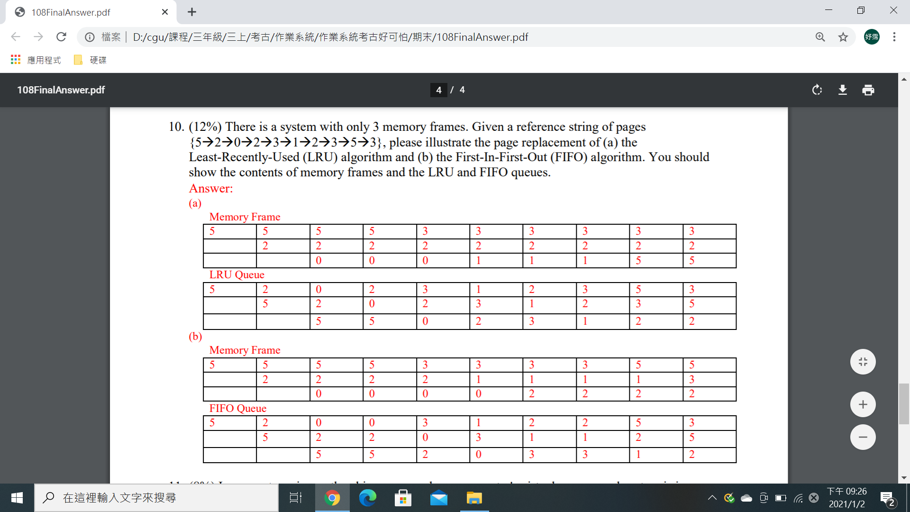

**11.** In computer science, thrashing occurs when a computer's virtual memory subsystem is in a constant state of paging, rapidly exchanging data and binaries in memory for data and binaries on disk. (a) Please use the following figure to provide one possible reason for causing trashing. (b) Please provide a solution to address the problem is question (a).

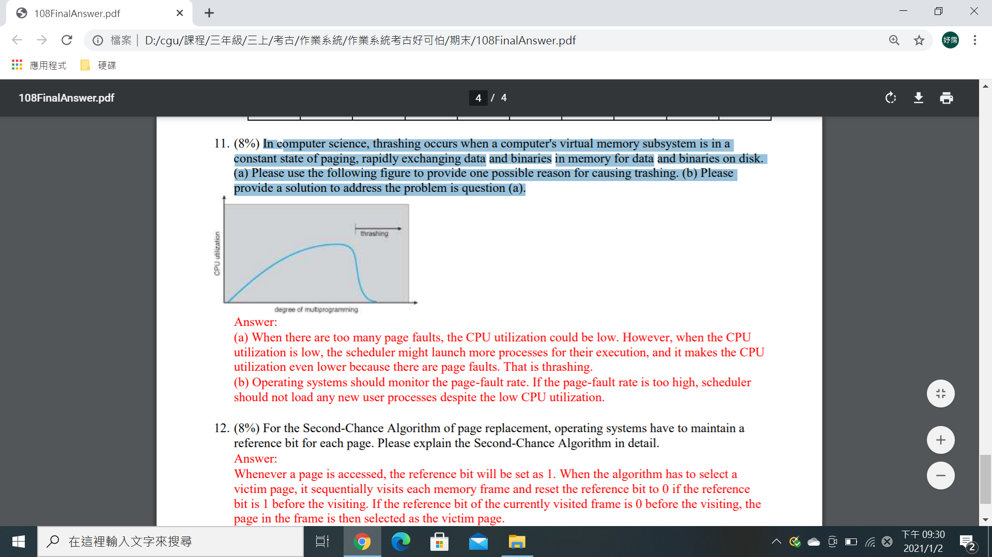(a)當頁面錯誤過多時，CPU的利用率可能降低，但是當CPU利用率低，scheduler可能會啟動更多processes來執行他們，它會使CPU的利用率變的更低，因為page faults，That is trashing.

(b)Operating system應監視page-fault rate，如果page-fault rate太高，儘管CPU的使用率低，scheduler也不能載入new user processes.

**12.** For the Second-Chance Algorithm of page replacement, operating systems have to maintain a reference bit for each page. Please explain the Second-Chance Algorithm in detail.

Ans：Whenever a page is accessed, the reference bit will be set as 1.當演算法選擇一個victim page，它會循序的訪問每個memory frame和reset reference bit to 0(如果reference bit在訪問前為1)。如果在訪問前當前訪問的frame的reference bit是0，the page in the frame會選擇作為victim page.

**107**

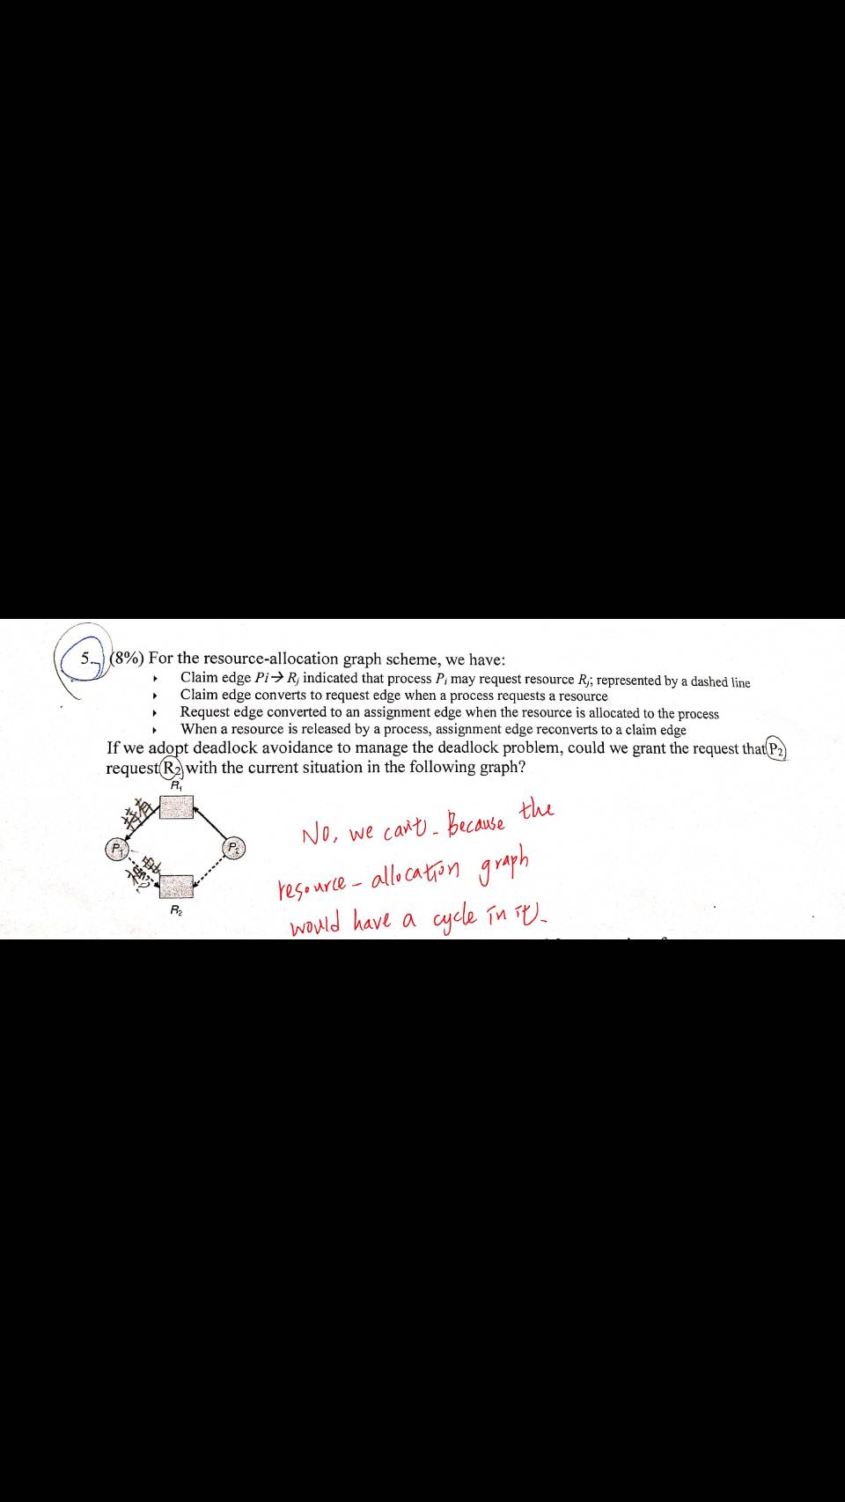

**106**

**1.**Please (a)define ”Race Condition” and (b) provide an example for Race Condition. You can use the case, counter++ and counter - - are in two different process, as the example.

(a)一種執行結果depends on particular order of process scheduling的解決方法

(b)One counter++ and one counter - -

r1=counter r2=counter

r1=r1+1 r2=r2-1

counter=r1 counter=r2

Initially, let counter=5

1.P: r1=counter 2.P: r1=r1+1

3.C: r2=counter 4.C: r2=r2-1 => A race condition!

5.P: counter=r1 6.C: counter=r2=4

The result can be 4, 5 or 6

**3.**Please defined (a) deadlock prevention and (b) deadlock avoidance

Ans: (a) 防止出現deadlock的必要條件

(b) 確保系統始終處於”安全”狀態 (By Banker’s algorithm)

**6.**Please defined (a) external fragmentation and (b) internal fragmentation of memory management. If we use “Paging” to manage memory, (c) is it possible to have external fragmentation? (d) is it possible to have internal fragmentation? You have to provide reasons for the answers of sub-questions c and d.

Ans: (a) External Fragmentation –所有memory空間存在滿足一個request，但是不連續的

(b) Internal Fragmentation – 分配的memory可能比請求的memory稍大，這種大小差異是記憶體內部切割造成，但沒有被使用

(c) 否，所有memory均以page大小劃分，且所有請求均以page為單位

(d) 是，如果我們只需要3 KB的記憶體空間，則在分配的4 KB page中將有1 KB的internal fragmentation

**9.**Please explain when will Second-Chance algorithm change a reference bit from 0 to 1

Ans: 當page 被引用時(read or written)，對應的reference bit 將設置為1

11. In the final project, we have used the following four command. Please explain the purposes for using the four command(a)make (b)sudo insmod hello.ko (c) sudo rmmod hello (d)dmesg

Ans: (a)build the kernel module

(b)insert the kernel module

(c)remove the kernel module

(d)print the message buffer of the kernel

**105**

**4.** To manage deadlocks, an OS can run Banker’s Algorithm to avoid deadlock. If an OS does not do deadlock avoidance, the OS has to do deadlock detection. When deadlocks are detected, the OS will do system recovery from the deadlocks. (a) When should we choose deadlock avoidance instead of deadlock detection? (b)When should we choose deadlock detection instead of deadlock avoidance?

Ans: (a)當從deadlock復原的成本過高，且系統有時會出現deadlock

(b)當系統可以容忍deadlock且系統很少有deadlock

**9.**Copy-on-Write(COW)allows both parent and child processes to initially share the same pages in memory. So please explane the details of COW.

Ans: Copy-on-write 允許parent和child process 最初共享memory中的相同page。如果任一process修改了共享的page，則該page將被複製。由於只複製修改的page，因此可更有效的創建process

**104**

1. Assume that you are an OS genius and helping Peterson to revise his algorithms for protecting the critical sections of processes Pi and Pj. (1) Please illustrate the problems of Algorithm 1 and Algorithm 2. (2) Please provide Algorithm 3 which can properly mange the critical sections of Pi and Pj, and make sure that Algorithm 3 can meet the requirements of Mutual Exclusion, Progress, and Bounded Waiting

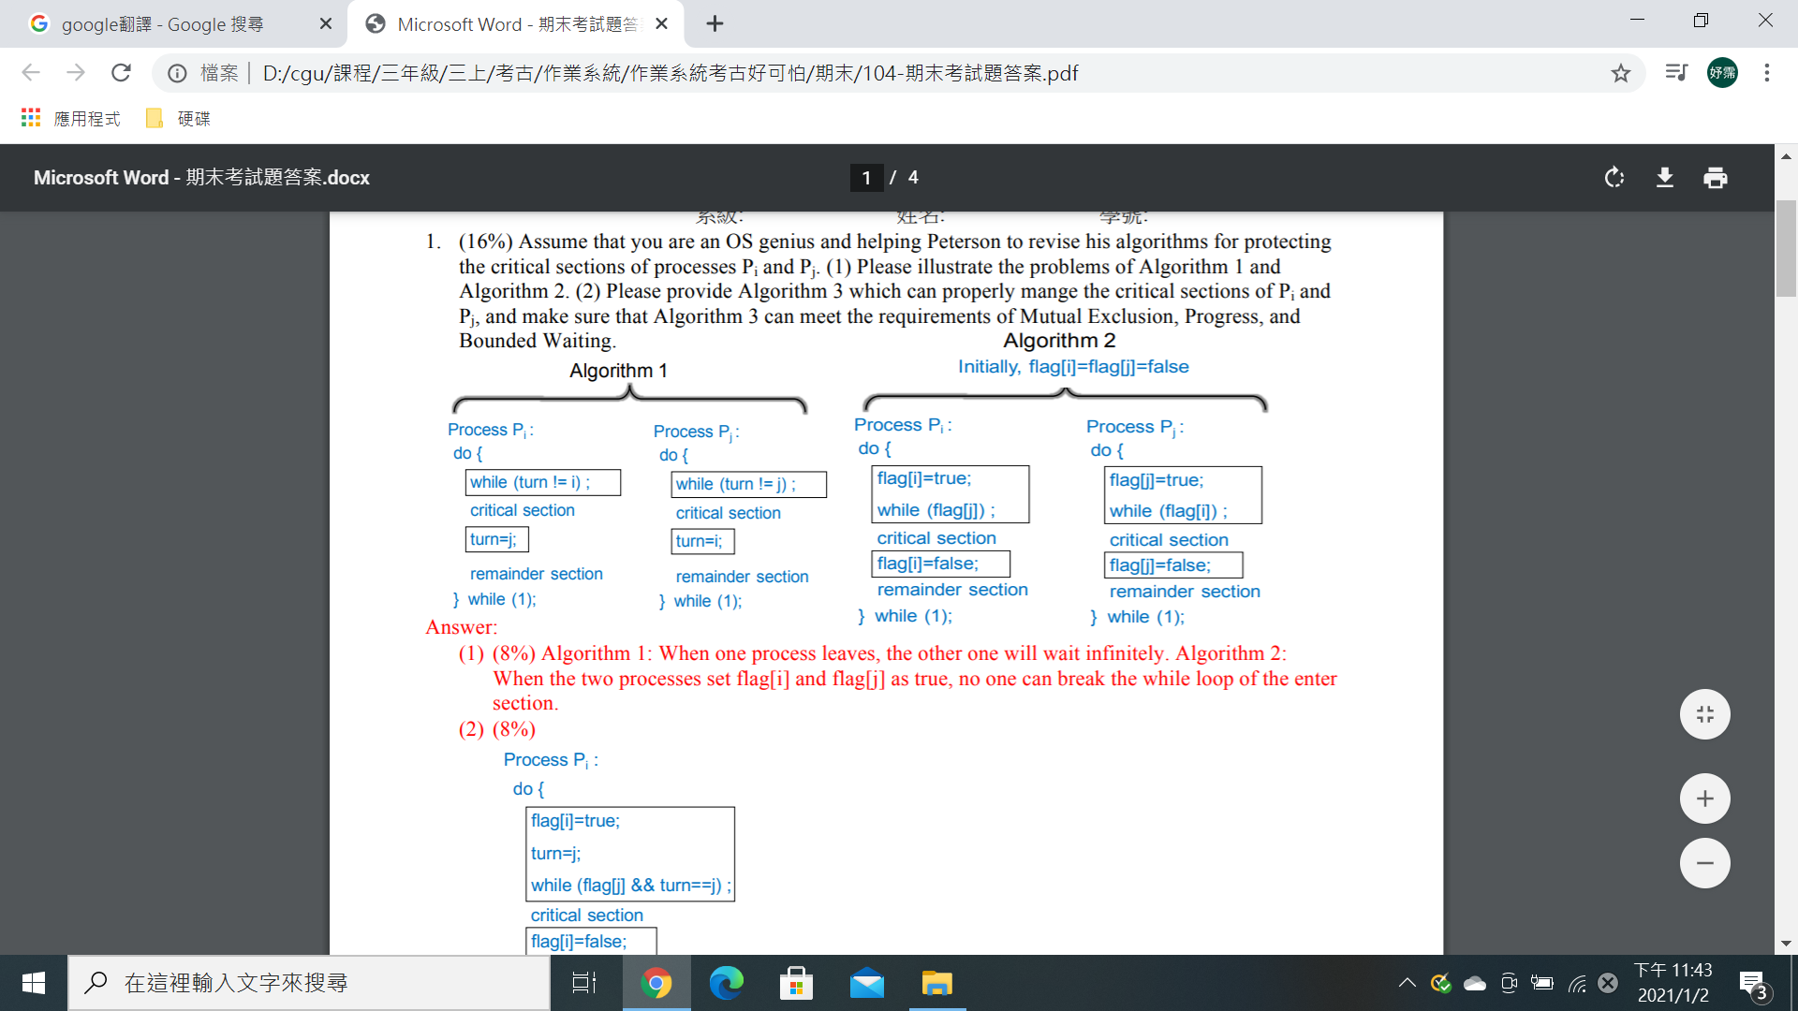

Ans: (1)Algorithm 1:當一個process離開時，另一個process將無限期等待。Algorithm 2:當兩個processes將flag[i]和flag[j]設置為true時，沒有人可以中斷enter section的while loop

(2)

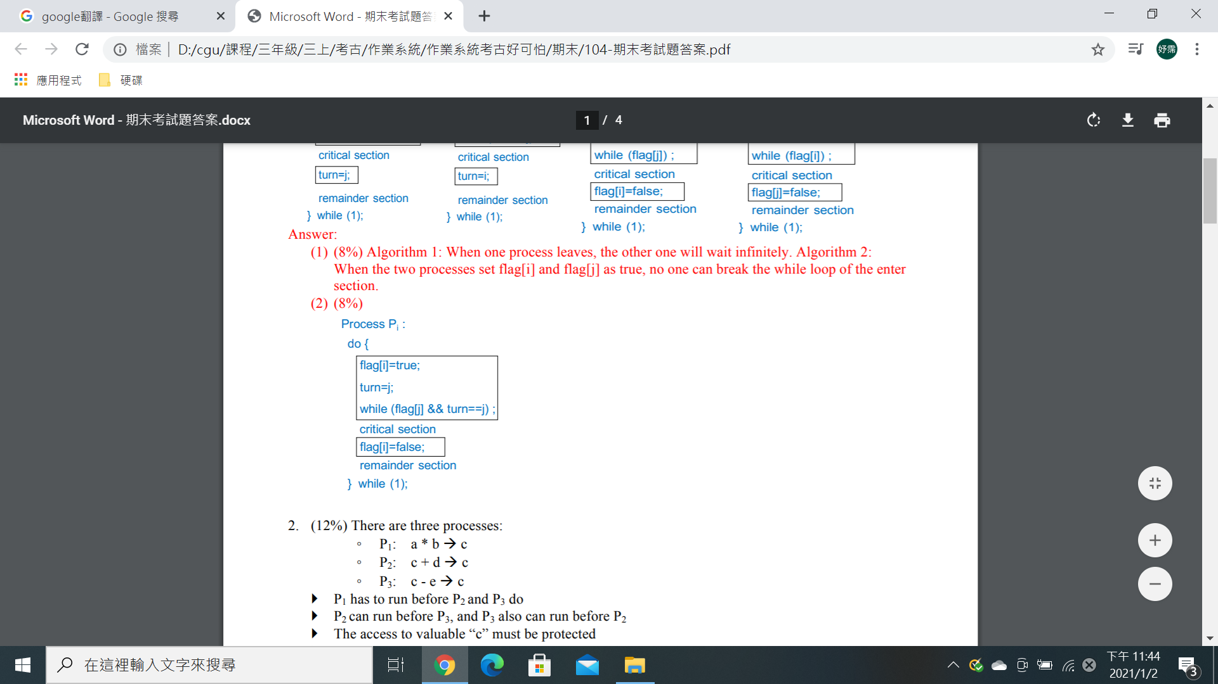

**5.**Please defined (1)local address (2)physical address (3)static link (4)dynamic link (5)external fragmentation, and (6) internal fragmentation of memory and address management.

Ans: (1)CPU所產生，又稱為virtual address

(2) address seen by the memory unit

(3)系統函式庫和原始碼被loader結合成binary program image

(4)連結推遲到執行時間

**6.** For the inverted page table architecture, please define the (1) pid, (2) p, (3) d, and (4) i of the following figure. (5) Please briefly explain the mechanism of inverted page table architecture for getting the physical address.

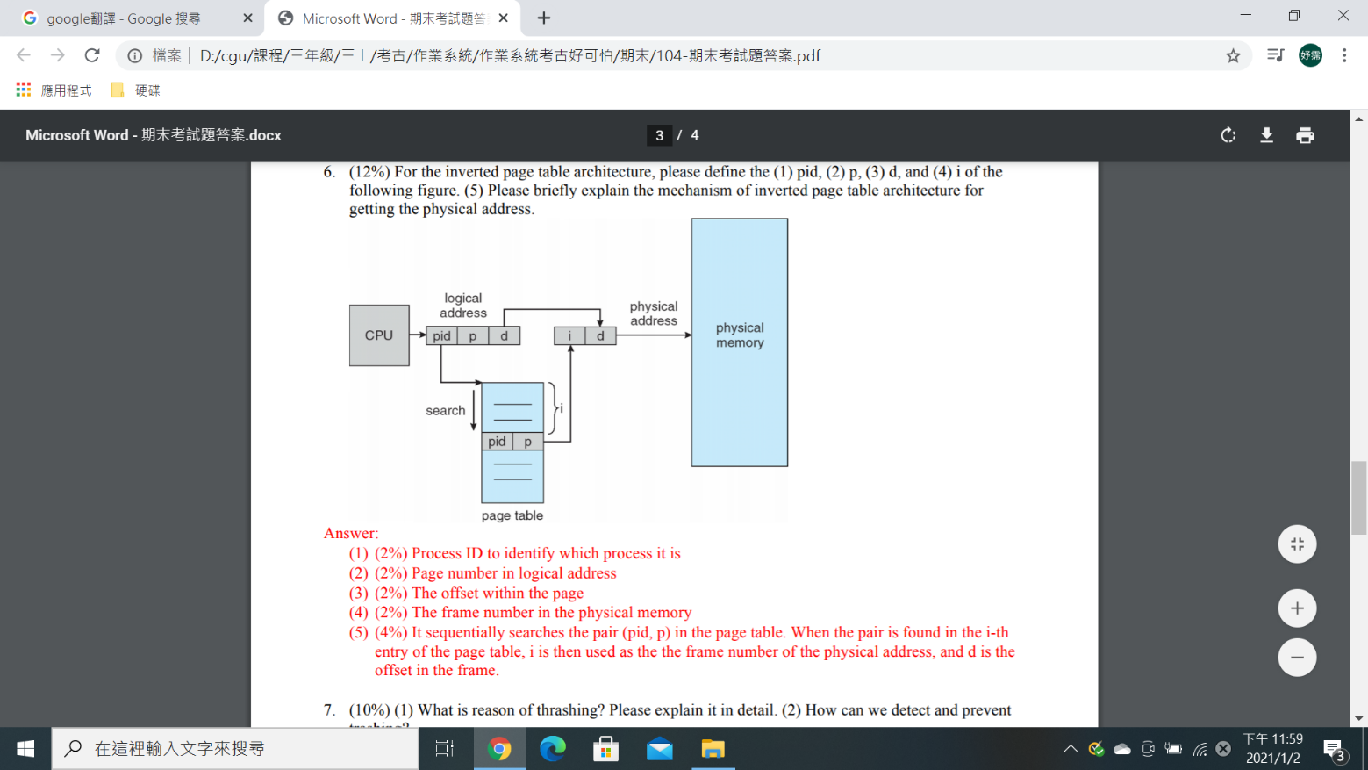(1)processID以標示它是哪個process

(2) Page number in logical address

(3) page中的

(4) physical memory中的frame number

(5) 108-8

**103**

**3.** Deadlock prevention is to prevent the necessary conditions which can form the deadlock problem. One of the necessary conditions is Mutual Exclusion. Please list the other three necessary conditions.

Ans: Hold and Wait, No Preemption, Circular Wait

**6.** For a system with a page table and a TLB, as shown in the following figure, please explain the meaning of the numbers p, d and f in the figure.

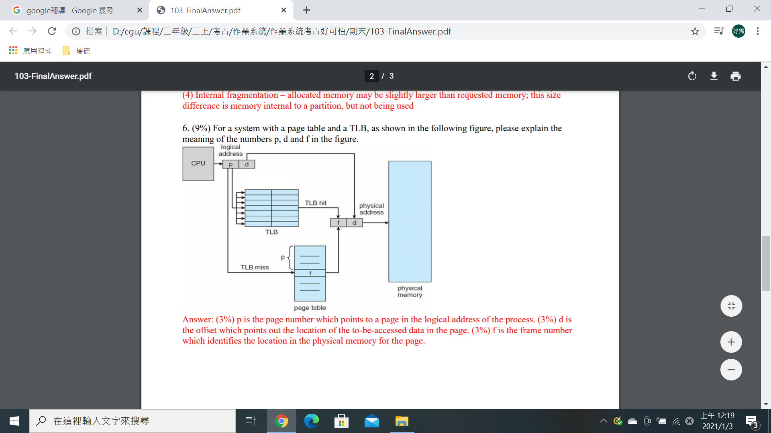Ans: p是page number，指向process的logical address中的page。d是offset，指出page中要訪問的數據位置。f是frame number ，它標記page在physical memory中的位置。

**7.** Virtual memory is a technique that allows the execution of a process that may not be completely in memory. Please provide at least one potential benefit for using virtual memory.

Ans:由於process占用較少的physical memory，因此multiprogramming的level 增加了

**9.** There are a lot of file systems supported by various operating systems. In order to provide unified file-system interface, the concept of the virtual file system is proposed. Thus, in the following figure, please list what are (1), (2), (3), and (4). Hint: they could be Local File System Type 2, Remote File System Type 1, File-System Interface, and Virtual-File-System Interface

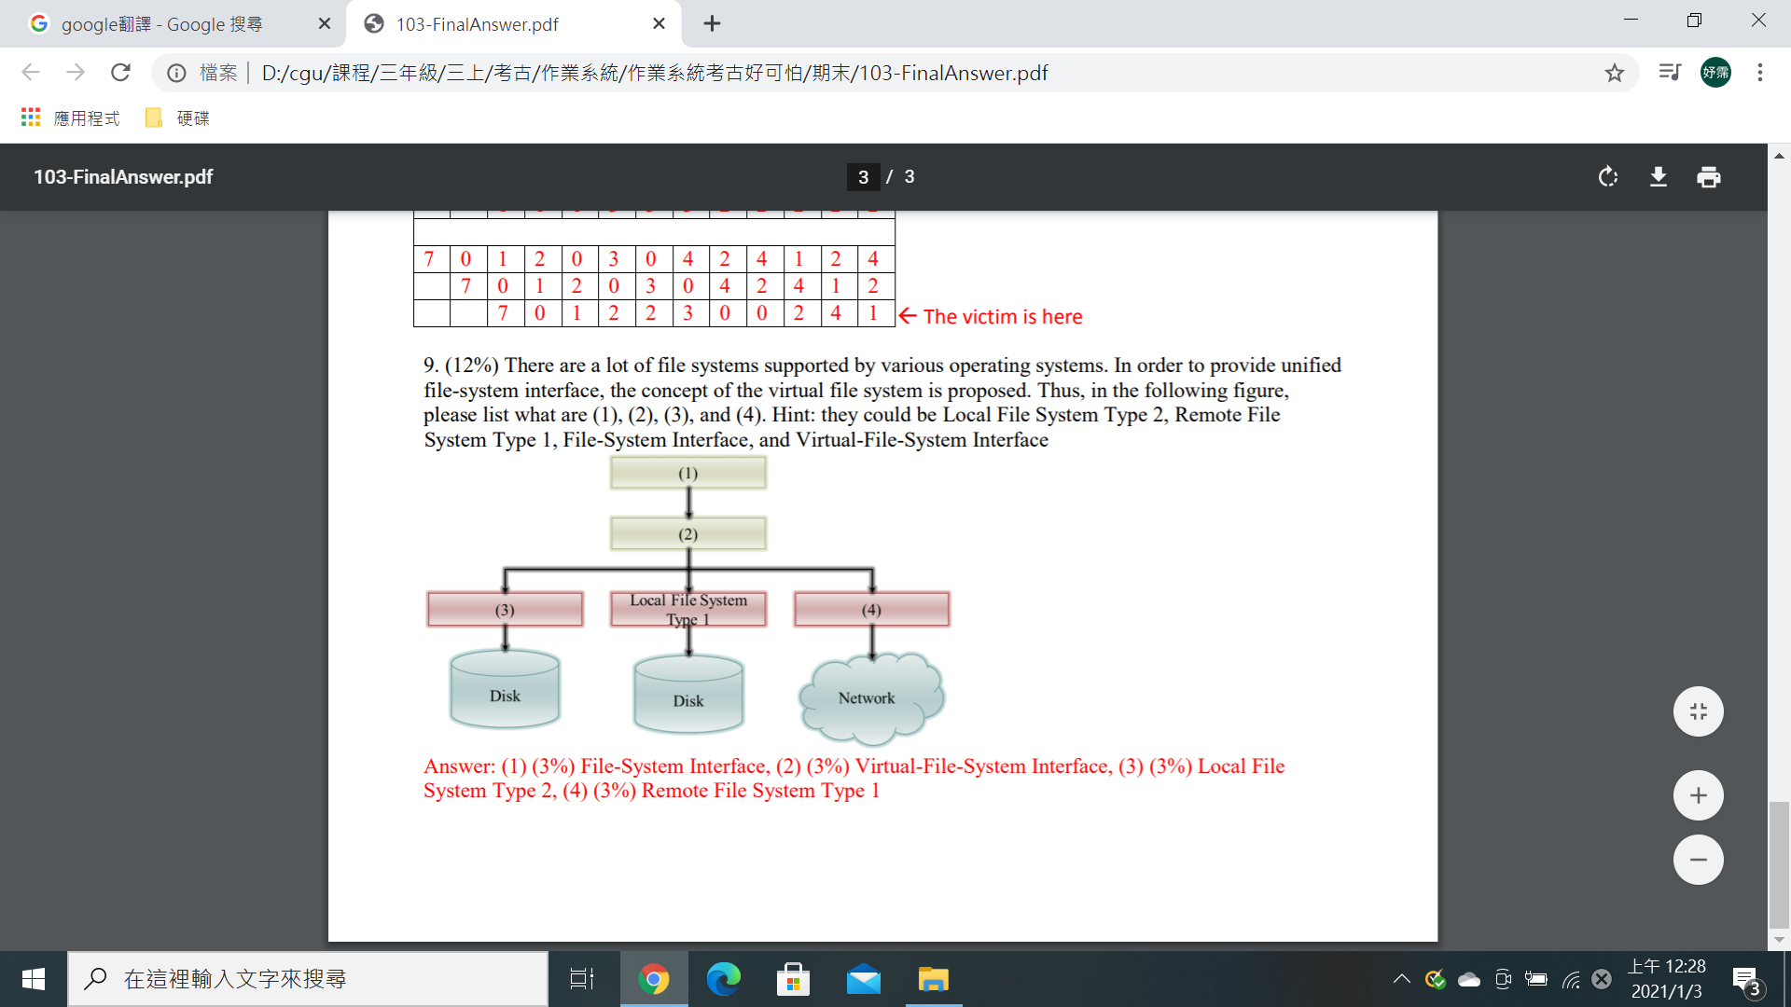(1)File-System Interface

(2)Virtual-File-System Interface

(3)Local File System Type 2

(4)Remote File System Type 1

**102**

**5.**define what is

Ans: TLB是page table的快取，它是一種short access latency的SRAM，用於減少page table讀取數據的時間

7. (1) What is the benefit for increasing the degree of multiprogramming of a multi-core system? (2) Please define “Trashing.” (3) How can we detect that a system is in a trashing state?

Ans: (1)提高多元程式規劃的程度有可能提高多核的利用率

(2)系統正忙於換入和換出page

(3)觀察rate of page faults，如果在多元程式規劃的程度增加時速率迅速增加，則可能處於tTrashing